**QUALITY CONTROL ANALYTICS IN MANUFACTURING**

**SECTOR**

GOKULNATH K & E24755

**Overview**

Quality control analytics in manufacturing leverages data analysis to ensure product quality and optimize production efficiency. Data analysts collect and scrutinize data from production processes, using statistical methods like control charts to monitor variability and identify trends. Predictive models forecast potential defects, enabling proactive maintenance and adjustments. Root cause analysis techniques address underlying issues when quality problems arise, while real-time monitoring systems provide immediate feedback for corrective action. Through detailed reporting and dashboards, analysts support continuous improvement efforts, reducing waste, cutting costs, and enhancing overall product reliability.

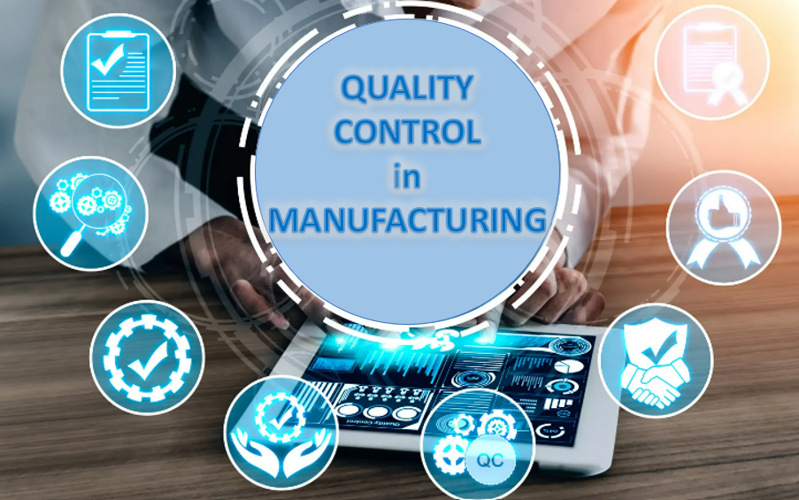

**Objective**

* **Early Defect Detection:** Identify defects early to reduce defective products and minimize rework.
* **Process Stability:** Monitor and maintain process stability using statistical tools.
* **Predictive Maintenance:** Forecast potential failures to enable proactive maintenance.
* **Root Cause Analysis:** Analyze and address the underlying causes of quality issues.
* **Process Optimization:** Enhance manufacturing processes for better quality and efficiency.
* **Informed Decision-Making:** Provide actionable insights through reports and dashboards.
* **Customer Satisfaction:** Ensure products meet quality standards to improve customer satisfaction.
* **Cost Reduction:** Lower costs related to defects and waste.
* **Regulatory Compliance:** Ensure adherence to industry standards and regulations.
* **Continuous Improvement:** Support ongoing improvements by tracking and analyzing data.

**Assigned Task(s)**

* Quality Control Analytics - Manufacturing Sector

**Task Details**

● **Task 3:** Quality control analytics in manufacturing focuses on using data to maintain and improve product quality. Analysts monitor production data with statistical tools to detect defects early and ensure process stability. Predictive models anticipate potential issues, allowing for preemptive maintenance. Root cause analysis identifies underlying problems, while real-time monitoring enables immediate corrective actions. Detailed reports and dashboards help in making informed decisions, driving continuous improvements, and reducing costs.

● **Status:** Completed

● **Details:**

**1. Data Collection and Integration**

* **Sensor and Equipment Data:** Data is collected from various sensors embedded in machinery, capturing real-time metrics such as temperature, pressure, and operational speed. This data provides insights into the functioning and performance of equipment.
* **Inspection and Testing Data:** Includes results from quality checks performed manually or via automated inspection systems. Metrics might include product dimensions, surface defects, and material properties.
* **Historical Quality Records:** Historical data is aggregated to identify trends and patterns. This includes past defect rates, production volumes, and quality issues documented over time.

**2. Statistical Process Control (SPC)**

* **Control Charts:** Utilized to monitor the consistency and stability of the manufacturing process. Control charts track process performance over time, highlighting variations that may indicate potential problems.
* **Process Capability Analysis:** Measures how well a process can produce products within specified limits. This analysis helps in assessing the capability of the process to meet quality standards.
* **Variation Analysis:** Identifies and quantifies sources of variability in the manufacturing process, helping to pinpoint areas where consistency can be improved.

**3. Predictive Analytics**

* **Predictive Modeling:** Uses historical and real-time data to build models that predict potential equipment failures or quality issues.
* **Trend and Pattern Analysis:** Analyzes data trends and patterns to anticipate quality issues or equipment malfunctions. This proactive approach allows for timely interventions and maintenance scheduling.
* **Risk Assessment:** Evaluates the likelihood and impact of potential quality problems, guiding prioritization of maintenance and process adjustments.

**4. Root Cause Analysis**

* **Data Mining:** Extracts and analyzes data to identify the root causes of defects and quality issues. This involves examining correlations between different variables and process factors.
* **Analysis Techniques:** Employs methods such as Pareto analysis (80/20 rule), fishbone diagrams, and Failure Mode and Effects Analysis (FMEA) to systematically identify and address underlying issues.
* **Corrective Action Implementation:** Develops and implements corrective actions based on root cause findings to prevent recurrence of quality issues.

**5. Real-Time Monitoring**

* **Live Data Tracking:** Continuously monitors production processes to detect deviations from quality standards as they occur. Real-time data allows for immediate adjustments and corrections.
* **Alert Systems:** Sets up automated alerts and notifications for process deviations, out-of-spec conditions, or equipment malfunctions, enabling quick responses.
* **Immediate Corrective Actions:** Facilitates rapid response to quality issues detected through real-time monitoring, reducing the likelihood of defective products reaching the market.

**6. Reporting and Visualization**

* **Dashboards:** Creates interactive dashboards that visualize key quality metrics, process performance, and trends. Dashboards provide a comprehensive view of quality data for easy interpretation.
* **Trend Reports:** Generates reports that track quality trends over time, highlighting improvements, issues, and areas needing attention.
* **Decision Support:** Provides detailed insights and recommendations to support strategic decision-making, process improvements, and quality management.

**7. Continuous Improvement**

* **Ongoing Data Analysis:** Regularly reviews and analyzes data to identify opportunities for process enhancements and quality improvements. Continuous data evaluation helps in refining processes and practices.
* **Feedback Integration:** Incorporates feedback from quality control findings into process optimization strategies. Insights gained from data analytics drive continuous refinement of manufacturing practices.
* **Implementation of Best Practices:** Adopts industry best practices and data-driven improvements to enhance process efficiency, product quality, and operational performance.

**Progress**

● **Accomplishments:** Accomplishments in quality control analytics for the manufacturing sector include significantly reducing defect rates by implementing predictive models that identify potential issues before they impact production. Enhanced process stability and efficiency are achieved through continuous monitoring and statistical analysis, leading to more consistent product quality. Additionally, actionable insights from detailed reporting and dashboards drive informed decision-making, fostering continuous improvement and operational excellence.

● **Metrics:** In quality control analytics for manufacturing, key metrics include Defect Rate, which measures the percentage of defective products out of the total produced, and often aims for a reduction to less than 1% as an indicator of progress. Process Capability Index (Cp/Cpk) assesses how well a process meets quality specifications, with a Cp/Cpk value of 1.33 or higher typically signifying an acceptable level of performance. First Pass Yield (FPY) tracks the percentage of products passing quality checks without rework, with improvements showing an increase from baseline levels, often targeting a FPY of 95% or above to demonstrate enhanced process efficiency.

**Challenges and Solutions**

● **Challenges Faced:**

* Large volume of data require robust filtering processes to ensure the data quality
* Data often resides in silos, hindering comprehensive analysis and insights
* Not Enough Skilled workforce
* Data quality in poor conditions leads to erroneous conclusions, incorrect decisions, and a waste of resources.

● **Solutions Implemented:**

* Use automated tools for data cleaning and filtering to manage large volumes effectively.
* Implement systems that consolidate data from various sources to eliminate silos and improve analysis.
* Provide training to enhance the skills of data analysts in modern analytics techniques and tools.
* Conduct regular data audits and validation checks to maintain high data quality and accuracy.

**Next Steps**

**● Upcoming Tasks:** To get ready planned for the next tasks.

● **Goals:**

* Check what was achieved and what’s pending.
* Identify the most important tasks for the next day.

**Conclusion**

● **Summary:** Quality control analytics in the manufacturing sector enables data analysts to significantly enhance product quality and operational efficiency. By applying statistical tools and predictive models, analysts can monitor processes, identify defects early, and anticipate potential issues. This proactive approach allows for timely interventions and continuous improvements. Detailed analysis and reporting provide valuable insights for informed decision-making, ultimately leading to reduced costs and improved product reliability. Effective quality control analytics is crucial for maintaining high standards and driving operational excellence.

● **Acknowledgments:** Thank you all for your time and attention today. Your engagement and interest in quality control analytics are greatly appreciated. We hope the insights shared will contribute to your understanding and implementation of effective quality control practices in the manufacturing sector.